 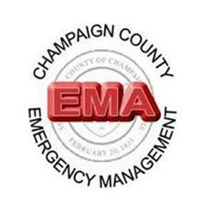

**VRC**

**Volunteer Reception Center**

**Training**

At the ILEAS Training Center, 1701 E Main St., Urbana, IL 61802

April 5, 2025, 8:00 am-4:00 pm

A Volunteer Reception Center (VRC) provides a place where large numbers of volunteers can be efficiently processed and referred to agencies needing their services in an emergency or disaster.

This process provides an easy way to document volunteers being registered, requests for volunteers, VRC hours worked, and expenses incurred. A VRC is a perfect staging area and location for volunteers to wait for assignments to assist their community.

This training is **free.**

**Register at:** [**ema@co.champaign.il.us**](mailto:ema@co.champaign.il.us)

