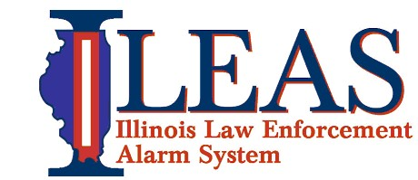
Communications Equipment Technician
Section: Communications
Reports to: SWIC/ILEAS Administration
Supervises: N/A
FLSA Status: Nonexempt

Job Summary
Under general supervision of the Statewide Interoperability Coordinator (SWIC), applies technical skills and training in performing a wide variety of duties relating to, testing, maintaining and making minor repairs to equipment associated with the Illinois Law Enforcement Alarm System (ILEAS) communications system, including, but not limited to, base and mobile two-way radios, antenna systems, solar power generators, and other electronic communications used by the agency.
Job Duties
- Tests and repairs a variety of electronic communications instruments to include land mobile radio (LMR), digital and satellite-based voice, data and video systems.

- Requires the ability to disassemble and reassemble equipment to perform board-level repair, and feasible on mobile, portable, and base station radio equipment.

- Prepares and maintains technical records and reports. Must be able to use standard Office software, including Excel and Word.

- Performs other duties as required or assigned which are reasonably within the scope of the duties enumerated above.

- Requires knowledge and experience using standard land mobile radio test equipment including service monitors, and other specialized test equipment.

- Requires knowledge and experience in LMR technologies used in HF / VHF / UHF / 700-800 MHz radios, including Analog FM, APCO Project 25, Analog AM, and HF Single Sideband.

- Experience required in the, testing and repair of public-safety grade communications equipment used by ILEAS, including equipment produced by EF Johnson, Harris/MA COM, Kenwood, Motorola, Thales, and others in a service shop or public safety agency radio shop environment.

- Experienced in radio programming, including developing, modifying, evaluating, and testing radio configuration files, i.e. “codeplugs”. Must be familiar with change control processes with regard to codeplug versions.

Job Specifications:
- Knowledge, skill and mental development equivalent to the completion of two years of technical school with course work in electricity, electronics, and communications systems, or military communications technical training in the repair of communications equipment is recommended.
- Lifts and moves heavy communications and associated equipment. Requires ability to lift 75 pounds without assistance.
- Climbs, kneels and can perform strenuous activities in performance of assigned duties and responsibilities.
- FCC first or second class Radio Telephone Operator’s license or equivalent desired but not required.
- Working hours are flexible and can be arranged with permission of ILEAS management.
- Must be able to pass a background check conducted by the Illinois State Police.

WORK ENVIRONMENT
- Work will mainly be performed within the ILEAS Communications Work/Storage room. Working hours and times will be established based on assignments to be accomplished.
- This position works in a storage/work station setting and may require maintaining physical condition necessary for sitting for prolonged periods

The work environment characteristics described here are representative of those an employee encounters while performing the essential functions of this job. Reasonable accommodations may be made to enable individuals with disabilities to perform the essential functions.

GENERAL INFORMATION
The duties listed above are intended only as illustrations of the various types of work that may be performed. The omission of specific statements of duties does not exclude them from the position if the work is similar, related or a logical assignment to the position.

