JOIN US FOR THE

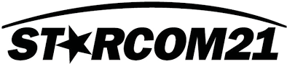

SWIT TEMPLATE/HANDS-ON TRAINING

**Assisted By**

**Contact Chief Allen**

**618-973-8579**

**ballen@fairmontcityil.com**

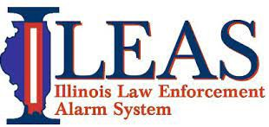

**Scan to Sign up**

**SESSION TIMES**

* **May 19, 2025 1800-2000**



**TOPICS INCLUDE**

 Radio system basics for users

The Interoperability Template:

Why we have it, and how to use it

Navigating the radio - Buttons, knobs, menus

* **May 20, 2025 0900-1100**



This class is designed to give participants a working knowledge of STARCOM21, how to work the radios, 

and how to use the Statewide Interoperability

Template (SWIT).

The class is geared for both new users, as well as existing users that need a refresher course.

**LOCATION**

Participants are strongly encouraged to bring their assigned radio to class for use in the hands-on portion.

After the class, participants will know how to operate on the correct channel or talk group for interoperability, depending on the situation.

**Fairmont City Community Center**

4001 Cookson Rd, Fairmont City IL 62201

