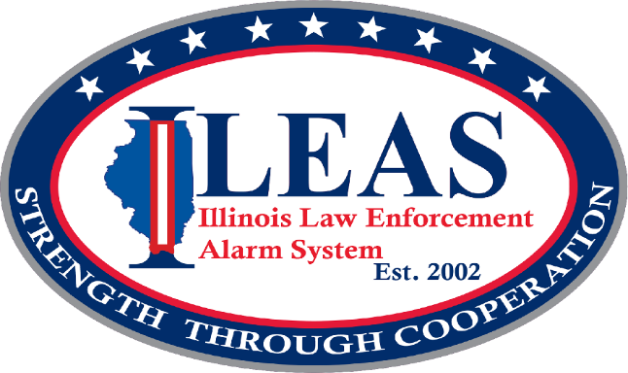

REQUEST FOR PROPOSALS

Less Lethal Alternatives for Law Enforcement Training

REQUEST FOR PROPOSALS – Less Lethal Alternatives for Law Enforcement Training

I. BACKGROUND

In conjunction with the SAFE-T (Safety, Accountability, Fairness and Equity – Today) Act, the Illinois Legislature (Grant #162606) identified a need to provide law enforcement officers with training on less lethal alternatives for violent, and potentially violent, encounters with the public during calls for service.

The Less Lethal Alternatives for Law Enforcement (LLA) training effort has the ability to have far-reaching effects beyond just officers and citizens in intense encounters. Officers will benefit on all of their interactions with citizens.

II. PURPOSE OF THE RFP

This request is for vendors and qualified independent instructors to submit proposals for Illinois Law Enforcement Training and Standards Board (ILETSB) certified instruction on less lethal alternatives to sworn law enforcement throughout Illinois.

III. GOAL OF THE TRAINING

The training will be provided throughout the State of Illinois with the goal of training as many sworn law enforcement officers, in as many locations as possible. The last day any training can be held is June 05, 2026.

IV. SCOPE OF WORK

The training shall be ILETSB certified as prescribed by the Illinois Criminal Justice Information Authority (ICJIA) and will focus on less lethal alternatives. Less lethal alternatives promote less lethal encounters between law enforcement and the public and may include training on how to avoid the use of force, de-escalation techniques, mediation, communication, and applicable human rights principles and standards. All approved classes must be administered in-person. Vendors are responsible for coordinating with ILETSB MTU Directors to ensure the officers attending training receive the state mandated training credits for each session offered.

The following is a non-exhaustive list of less lethal alternative training topics:

- De-escalation and non-escalation - Autism recognition
- Arrest control and pressure point control tactics - Procedural justice
- Co-responder and crisis intervention teams - Motivational interviewing
- Trauma-informed response and care - Mental health first aid (youth and adult)
- Cultural competency (implicit bias, racial and ethnic sensitivity)

V. COST ESTIMATES

Responses shall identify a total “package” cost for the entire training service proposed. The response must include enough detail to capture the cost of each training course and provide proof that the rate is consistent with what the respondent has historically charged for similar services. Cost for food and beverages are not covered by the agreement and may not be included in the proposal. The agreed total cost will be the only compensation paid to the successful candidate(s).

The funding allocated to the training portion of the Less Lethal Alternatives for Law Enforcement Grant for Illinois State Fiscal Year 2026 is $400,000. Therefore, no proposal shall exceed $400,000.

VI. PROPOSAL RESPONSE

All proposals shall include the following minimum requirements:

- Name of respondent
- Resume
- Title of training
- Synopsis and outline of the training
- Qualification of instructors
- List of 3 law enforcement references
- Proof of ILETSB certification, if available at time of proposal
- Organizational training plan to include locations
- Total number of trainings to be held
- Timeline for completion of all training (must be completed on or before (6/05/2026)
- Target number of attendees
- Cost per training course
- Total project cost

VII. COURSE FUNDING

Funding for the LLA training is made available from a state grant, provided through ICJIA and administered by ILEAS. The awarded proposal must meet all the requirements of the applicable grant.

Applicants selected through this proposal will be required to complete contractual agreements with ILEAS that are approved by ICJIA. These agreements include, but are not limited to, a budget and narrative describing the scope of the training.

VIII. PROPOSAL EVALUATIONS

Proposals will be evaluated by ILEAS in cooperation with ICJIA. The proposals will be evaluated on their overall ability to meet the goals and requirements of this RFP, the requirements of the grant, the quality and substance of the training proposed, and on the total costs associated with providing the training.

ILEAS reserves the right to pursue training from multiple vendors that respond to this RFP, or none. ILEAS reserves the right to pursue part of a training proposal without agreeing to the entirety of a proposal.

The selection of training will comply with ILEAS policy, the requirements of the ICJIA grant, and all applicable laws and regulations.

IX. PROPOSAL SUBMISSIONS

All proposals shall be submitted by October 24, 2025.

Proposals shall be submitted to: Scott Allen
LLAGrant@ILEAS.org

X. CONTACT

Scott Allen
Training Coordinator
Illinois Law Enforcement Alarm System (ILEAS)
1701 E. Main St.
Urbana, Il 61802
217-328-3800 Ext. 404
LLAGrant@ILEAS.org

